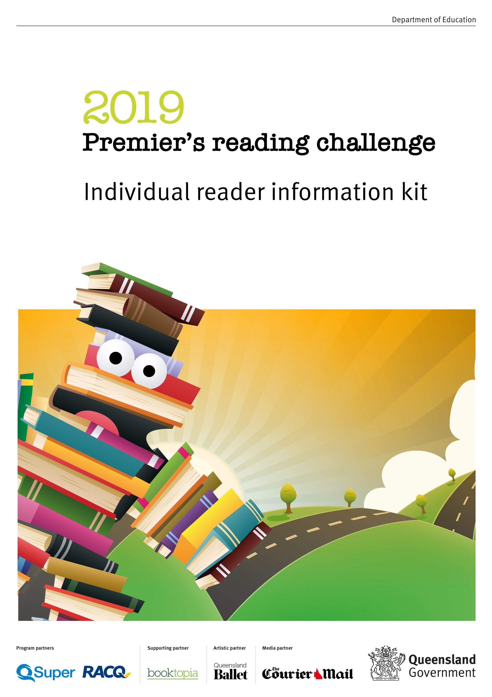

**Individual reader information kit**

**ABOUT THE CHALLENGE**

The Premier's Reading Challenge (PRC) is an annual statewide initiative for state and non-state schools and home-educated students up to Year 9, and children attending early childhood centres. Over the past 14 years, more than 12 million books have been read, and in 2018 alone, 181,000 school, early childhood and individual readers participated in the challenge with more than 2.46 million books read throughout the PRC reading period.

The challenge is not a competition but aims to improve literacy and encourage children to read widely for pleasure and learning. Students can participate in the challenge within their school or as individual readers (home-educated students or students whose schools are not participating in the program).

For a student to successfully complete the challenge they must read or experience the allocated number of books for their year level during the reading period. Students who complete the challenge have their efforts recognised through the receipt of a Certificate of Achievement signed by the Premier of Queensland.

**Why read?**

Literacy skills are vital to ensuring children have the best chance to succeed in their schooling and life. The PRC is an opportunity for students to be enthusiastic about reading, writing, authors and illustrators. Reading a variety of books builds vocabulary and knowledge, improves spelling and comprehension, can improve confidence and is also a great way to relax.

**Key dates**

|  |  |
| --- | --- |
| **Date** | **Activity** |
| 9 May 2019 | Registration opens for individual readers via the PRC database |
| 13 May 2019 | Reading commences for Prep – Year 9 students |
| 23 August 2019 | Reading finishes for Prep – Year 9 students Student reading record forms submitted to schools |
| 24 August – 6 September 2019 | Student reading achievements entered into the PRC database |
| October 2018 | Certificates of Achievement mailed to students  Certificate of Participation available for download |
| 4 – 15 November 2019 | PRC Celebration Weeks |

**Reading requirements**

While there is no compulsory reading list for the challenge, booklists have been developed in conjunction with the Department of Education’s (DoE) Reading Centre and the Global schools through languages team (State Schools – Performance), to help students, teachers, parents and guardians select age appropriate reading material. The booklists are available on the [Premier’s Reading Challenge website](https://readingchallenge.education.qld.gov.au/about/booklists) and have been divided into year level groups.

Students are encouraged to select a range of fiction and non-fiction books suited to their reading ability. Students are welcome to read books from previous years' booklists and from lists for other year levels.

Book titles are also available in Chinese, French, German Indonesian, Italian and Japanese. Students learning languages from Prep (or students with a family background in a language other than English) can choose to read or experience any books in additional languages to English as part of the challenge. Books in additional languages are not in year-level groups. Language teachers will be able to make decisions about appropriate books for students at their schools based on their understanding of students' level of language learning and their interests.

To successfully complete the PRC, students must read or experience the number of books indicated in the table below in English or additional languages. The requirement for Year 5 through to Year 9 students to read 15 books acknowledges that older students are likely to select longer, more complex books that may take them longer to read.

|  |  |
| --- | --- |
| **Year level** | **Number of books** |
| Prep – Year 2 | Read or experience 20 books |
| Years 3 – 4 | 20 books |
| Years 5 – 9 | 15 books |

If they have time, students are welcome to read more books than the challenge requirements. They just need to record them on another [reader record form](https://readingchallenge.education.qld.gov.au/how-to-register/downloads-and-forms). All books will go towards Queensland’s total PRC tally.

The following activities can be counted towards the challenge:

* reading independently
* shared reading
* being read to (Prep – Year 2 for books written in English; and all year levels for additional languages).

The following literature forms can be counted towards the challenge:

* printed books
* e-books, virtual books and digital publications
* graphic novels and comic books
* audio and braille books
* newspapers, magazines and recipe books
* books in additional languages (other than English).

**Certificates and prizes**

Certificates of Achievement will be mailed to homes of individual readers in October in time for the PRC Celebration Weeks. A Certificate of Participation will be available to download from the PRC website to reward participants for their reading achievements if they did not complete the challenge.

Individual readers who complete the challenge will be in the running for lucky draw prizes from PRC program sponsors.

**Celebration weeks**

Parents/guardians are encouraged to celebrate student reading achievements by holding home celebrations during the PRC Celebration Weeks from 4 – 15 November 2019.

**HOW TO PARTICIPATE**

This information kit is for students who are home-educated or students whose school is not participating in the PRC. Before registering as an individual reader, students attending a Queensland school should ensure their school is not participating in the challenge.

For your child to participate in the challenge as an individual reader, please follow the steps below.

|  |  |
| --- | --- |
| **Step 1: Register** Parent/guardian to register student to participate via the [PRC database](http://prc.median.com.au).For detailed instructions on how to register see page 6 of this information kit. | May – July 2019 |
| **Step 2: Download the reading record form** Download the individual reader record form from the [PRC website](https://readingchallenge.education.qld.gov.au/how-to-register/downloads-and-forms). Students who participate in the challenge can keep track of their progress by using the reading record form. |
| **Step 3: Reading period**  Students to read or experience the allocated number of books for their year level during the reading period. | 13 May – 23 August 2019 |
| **Step 4:** **Submit student achievements and preview certificates**  Parent/guardian to enter the number of books read into the PRC database, and preview the Certificates of Achievement to complete the challenge. | No later than  6 September 2019 |
| **Step 5: Celebrate reading achievements** Parents/guardians are encouraged to celebrate student reading achievements by holding home celebrations during the PRC Celebration Weeks. Certificates of Achievement will be mailed to the homes of individual readers in October in time for the Celebration Weeks. | 4 – 15 November 2019 |

**TIPS FOR PARTICIPATION**

**Encouraging students to read**

Parents, guardians, teachers, aides, siblings, student buddies and classmates play an important role in encouraging students to develop a love of reading. Some ideas to consider are:

* make time to read each day – ensure this time is fun and exciting
* suggest books, authors or themes your students may enjoy
* retell stories that you have enjoyed
* ask students to make book recommendations to others in class
* for students with language backgrounds other than English, encourage them to read books in their background language/s. Your local public library may have books available in additional languages and/or may be able to source books in additional languages to meet the needs of your community. The Brisbane School of Distance Education library (formerly the LOTE library) may also be able to assist with loans of books on the additional languages book lists.

**Encouraging your child to participate in the PRC**

* Make the PRC part of their daily or weekly routine
* Celebrate achievements throughout the challenge
* Keep the reading record form in a prominent place to showcase progress
* Download and print the bookmark from the PRC website for keep track of their reading progress.

**Entering book titles in additional languages on the PRC School reader record from**

Each of the book titles in additional languages includes the title of each book in English. Please record, or assist the students to record, the title and author in English and include the language for the book read.

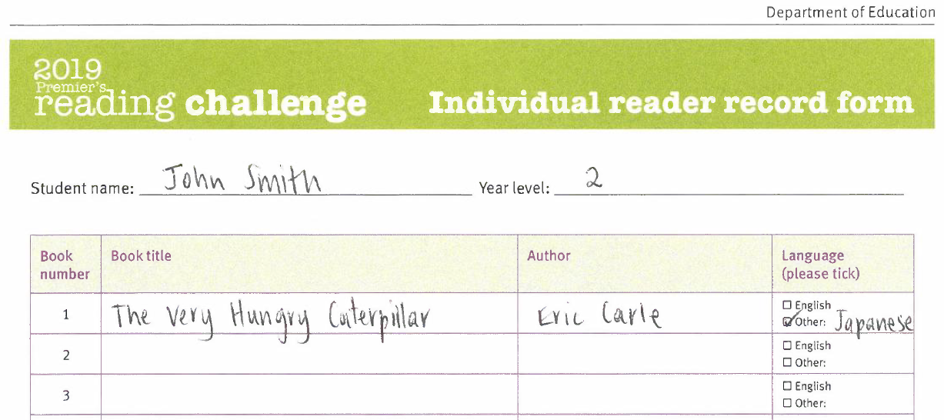

**HOW TO REGISTER**

Follow the steps below to register the child to participate in this year’s challenge.

**Step 1: Registration**

1. Open the PRC database - <http://prc.median.com.au>.
2. Click the ‘Register’ button on the PRC database home page.

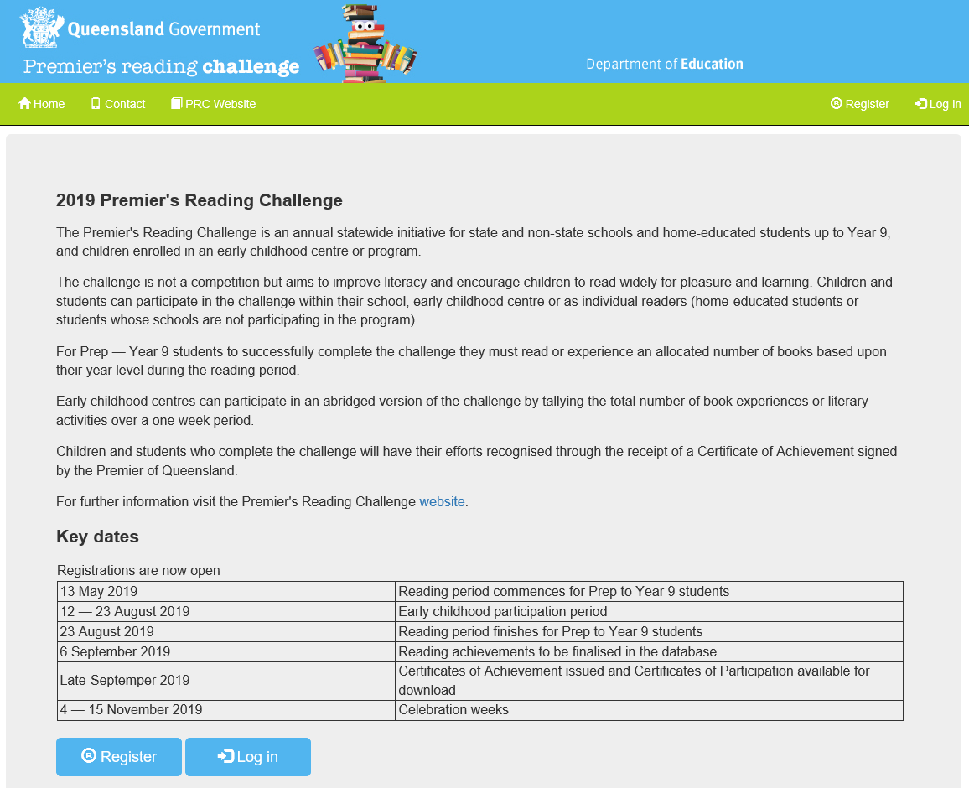

1. Click on the ‘Individual reader’ button. An individual reader is a Prep to Year 9 student who is home educated or whose school is not participating in the Premier’s Reading Challenge. Before registering as an individual reader, students attending a Queensland school should ensure that their school is not participating in the challenge.

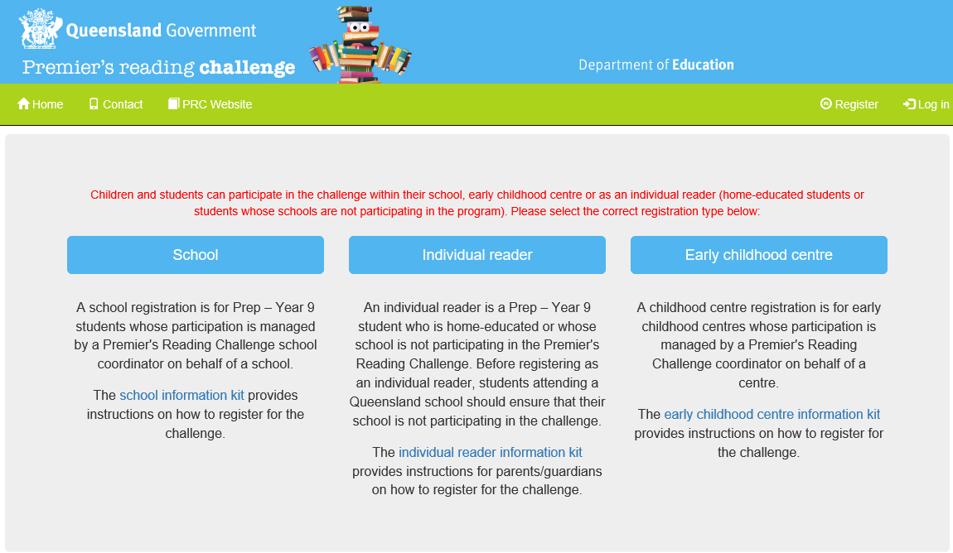

1. Enter your contact details and click the ‘Register’ button.

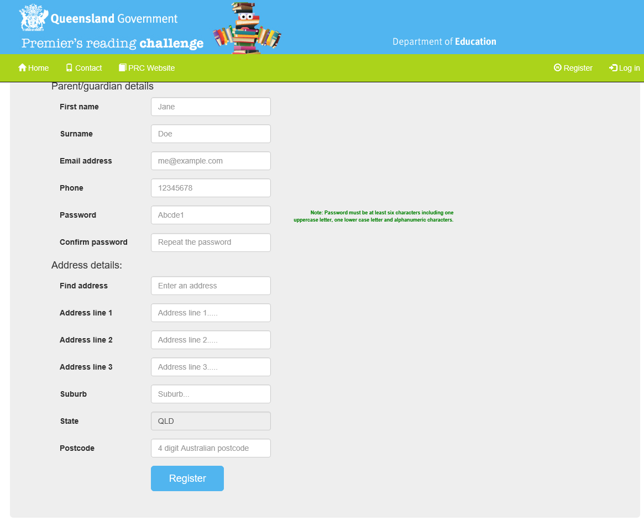

1. You will receive an email to confirm your registration from ‘Premier's Reading Challenge <PRC@median.com.au>’. The email will include your login details for the PRC database. Please keep these details as you will need to log back into the database throughout the challenge.
2. After you click the ‘Register’ button you will be taken to the ‘Participant details’ screen.

**Step 2: Enter participant details**

1. To enter a participant, click on the ‘Add child’ button on the right hand side of the screen.

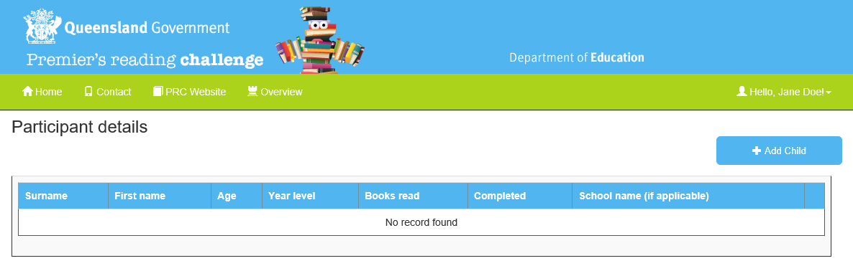

1. Enter all information for each participant as per the available fields. Once you have entered these details press ‘Save’. Please note the name as it appears in the database will be how it appears on the certificates.

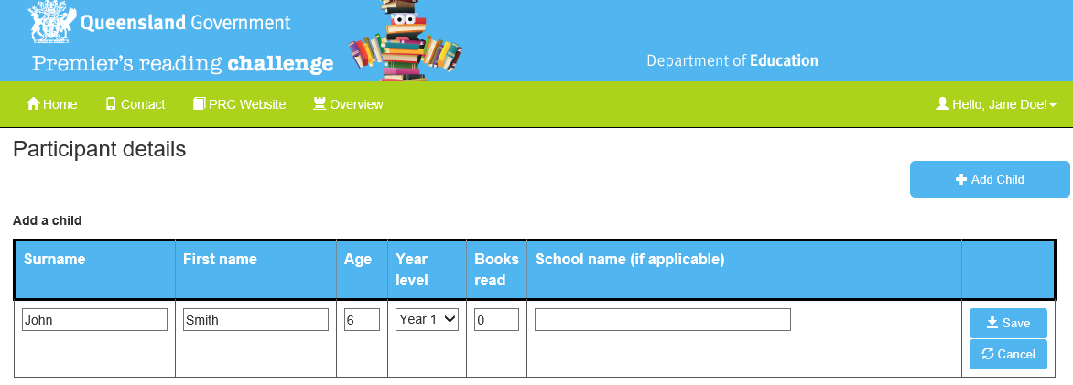

1. Repeat step 2 to add more participants.
2. You can **edit** or **delete** the participant by clicking ‘Edit’ or ‘Delete’ in the column on the right hand side of the screen.

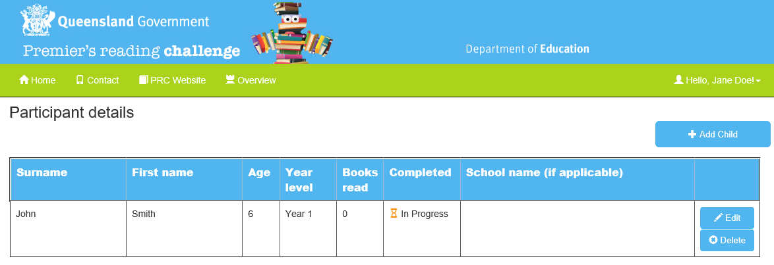

**Step 4: Update number of books read**

Throughout the challenge you are able to update the number of books participants have read by logging into the PRC database. Each participant needs to fill out their [Individual reader record form](https://readingchallenge.education.qld.gov.au/how-to-register/downloads-and-forms) for parents/guardians to enter into the PRC database by Friday 6 September 2019.

To enter the number of books read click the ‘Edit’ button next to the student’s name on the participant details screen. Enter the books read and click ‘Save’.

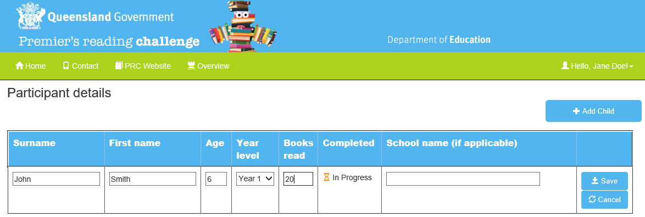

**Step 5:** **Completing the challenge**

Once all the books have been read and the final number has been added to the database, you can complete the challenge by clicking on the ‘Complete challenge’ button below.

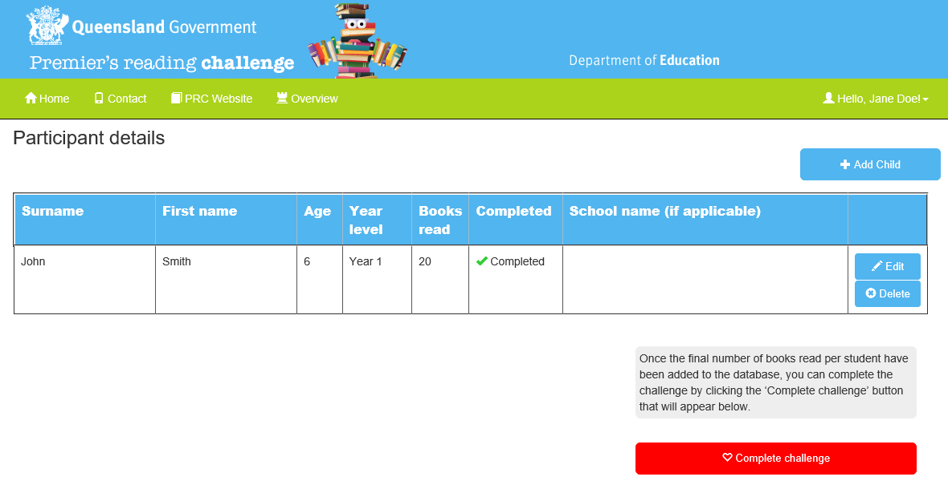

1. Preview the certificates

Preview certificates to ensure they have the correct student and school name. Click on the ‘Preview certificate’ button to be sent an email with the certificates attached.

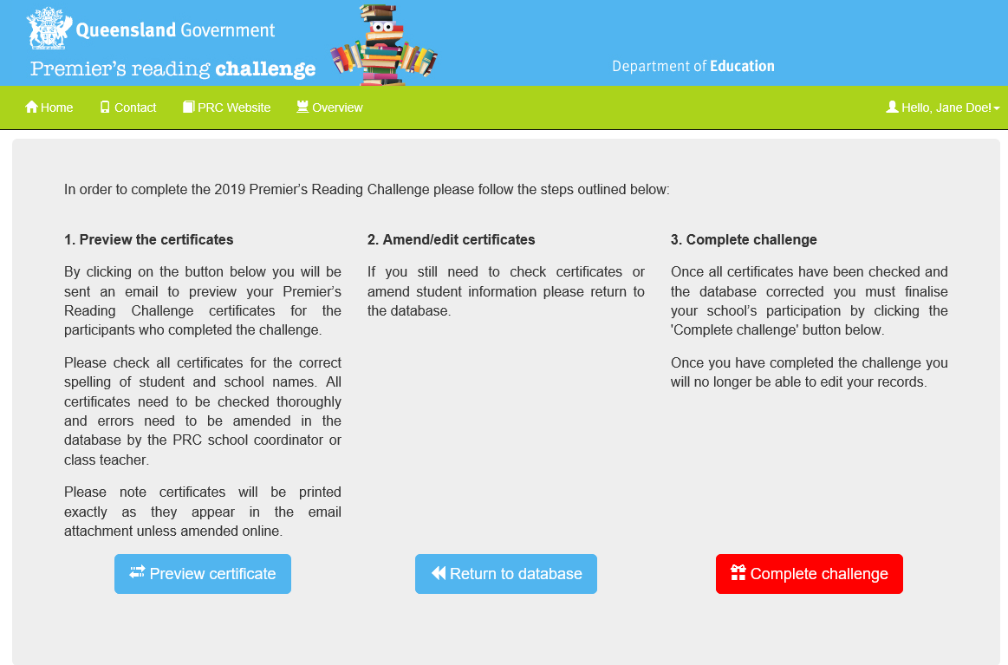

1. Amend/edit certificates

If the certificates need to be edited, click on the ‘Return to database’ button to make the required changes (as per Step 2 outlined above).



1. Complete challenge

Once all the certificates have been checked and any changes made, you can now complete the challenge by clicking on the ‘Complete challenge’ button below. Once you have completed the challenge you will no longer be able to edit your records.



1. Confirm postal address

Check that your postal details are correct (this is where the certificates will be sent) and click on ‘Confirm details and submit’. If you wish to change the postal address, go to the ‘My Account’ page which can be found in the drop down box under ‘Hello, *name*’ button in the top right hand corner of the screen.

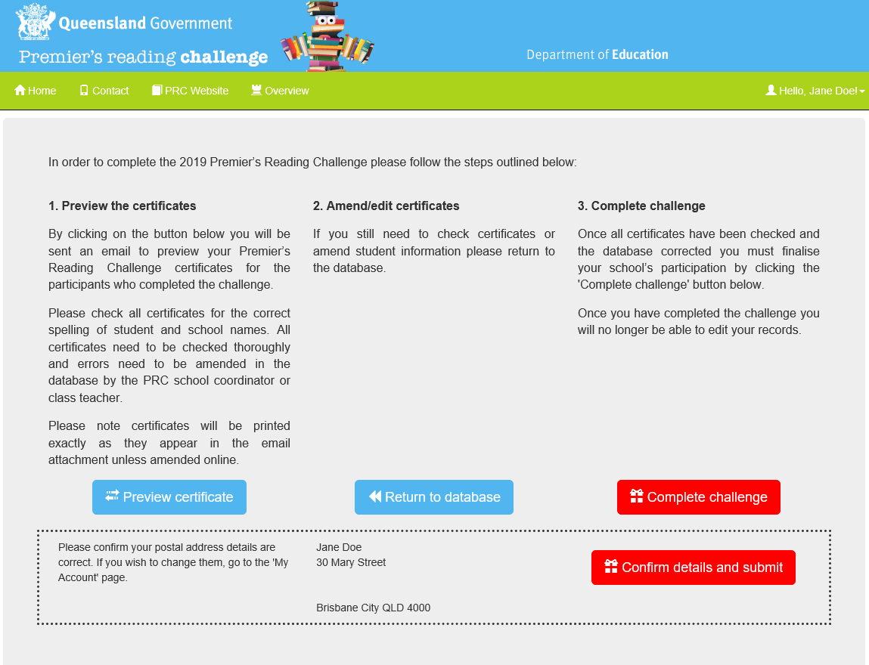

The text below will appear on the ‘Complete challenge’ page.

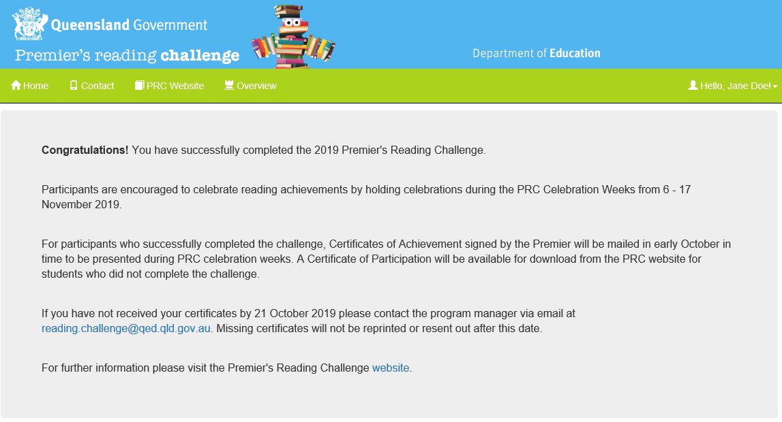

**How to change your details or password:**

If you need to change your details or password click the ‘Hello, *name’* button in the top right hand corner of the screen, and select ‘My Account’.

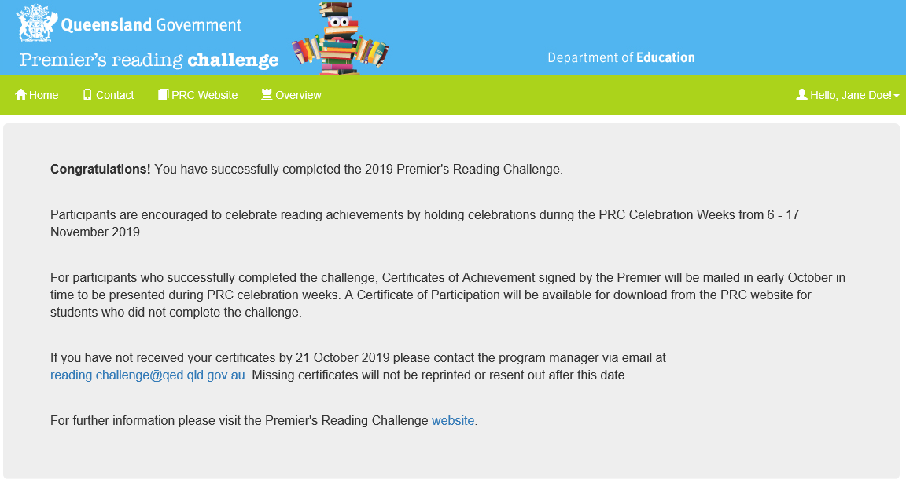

Change your password by selecting ‘Change’ at the bottom of the page.

Or update your details and select ‘Save’.

**LINKS AND RESOURCES**

PRC website: <https://readingchallenge.education.qld.gov.au/>

PRC database: <https://prc.median.com.au/>

DoE Reading Centre: <https://ahrc.eq.edu.au/>

DoE eBooks Digital Library: <https://intranet.qed.qld.gov.au/Services/InformationTechnology/elearning-training/eresource-services/ebooks/Pages/default.aspx>

State Library of Queensland: <http://www.slq.qld.gov.au/resources>

The Children’s Book Council of Australia: [http://cbca.org.au](http://cbca.org.au/)

DoE literacy fact sheets: <https://education.qld.gov.au/parents/Documents/factsheet-l-n.pdf#search=literacy>

Brisbane School of Distance Education library (for loans of books in additional languages): <https://brisbanesde.eq.edu.au/Supportandresources/discovery-centre/Pages/LOTE.aspx>

### Queensland public libraries

### State and Local Government work together to provide over 300 public libraries across Queensland. Find a [library](http://www.slq.qld.gov.au/visit-us/find-a-public-library) near you.

**Book suggestions from other state PRC programs**

New South Wales: <https://online.det.nsw.edu.au/prc/booklist/home.html>

South Australia: <http://www.premiersreadingchallenge.sa.edu.au/prc/pages/books/challenge/?reFlag=1>

Victoria: <http://www.education.vic.gov.au/about/events/prc/Pages/booklist.aspx>

**FURTHER INFORMATION**

Program Manager  
Premier's Reading Challenge  
Department of Education   
PO Box 15033  
City East QLD 4002  
Phone: (07) 3328 6628  
Email: [reading.challenge@qed.qld.gov.au](mailto:reading.challenge@qed.qld.gov.au)